BASIC NETWORK SNIFFER REPORT
CodeAlpha Cyber Security Internship
Project Title
Basic Network Sniffer Using Python
Submitted By
Prachiti Vartak

1. Introduction
Network communication is an essential part of modern computing systems. Every time a user accesses a website, sends data, or communicates over a network, information is exchanged through packets.
A network sniffer is a tool that captures and monitors these packets. It helps security professionals analyze network traffic, understand communication patterns, and detect unusual activities. In this project, a basic network sniffer was developed using Python and the Scapy library in Kali Linux.

2. Objective
The objectives of this project were:
• To understand network packet communication.
• To learn packet capturing techniques.
• To analyze live network traffic.
• To gain practical experience with Python in cybersecurity.
• To understand the basics of packet sniffing.

3. Tools Used
Operating System
Kali Linux
Programming Language
Python 3
Library
Scapy
Environment
Kali Linux Terminal

4. Methodology
The following steps were performed during the implementation of this project:
- A packet sniffer script was created using Python.
- The Scapy library was used to capture network packets.
- The script was executed with administrative privileges.
- Live network traffic was monitored.
- Captured packet information was analyzed.
- Observations and findings were documented.

Scapy library was installed and verified successfully before executing the network sniffer program.
screenshot
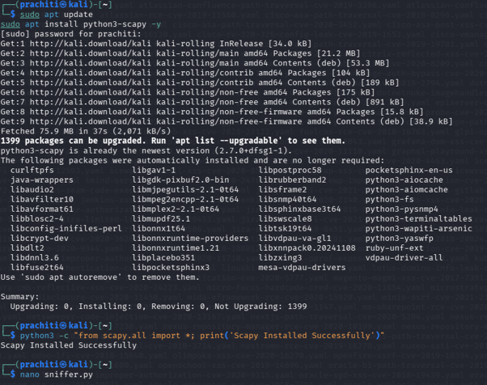

Figure 1: Installation and verification of the Scapy library in Kali Linux.

5. Code Implementation
from scapy.all import sniff

def packet_callback(packet):
print("\nPacket Captured:")
print(packet.summary())

print("Starting Packet Capture...")
sniff(count=10, prn=packet_callback)

print("\nCapture Completed.")
The above program captures ten network packets and displays a summary of each packet using the Scapy library.

6. Execution and Testing
The program was executed in Kali Linux using the following command:
sudo python3 sniffer.py
During execution, the packet sniffer successfully captured live network packets.
Sample output observed during testing:
Packet Captured:
Ether / IP / ICMP 10.0.2.15 > 192.178.193.102 echo-request

Packet Captured:
Ether / IP / ICMP 192.178.193.102 > 10.0.2.15 echo-reply

Capture Completed.

Screenshot
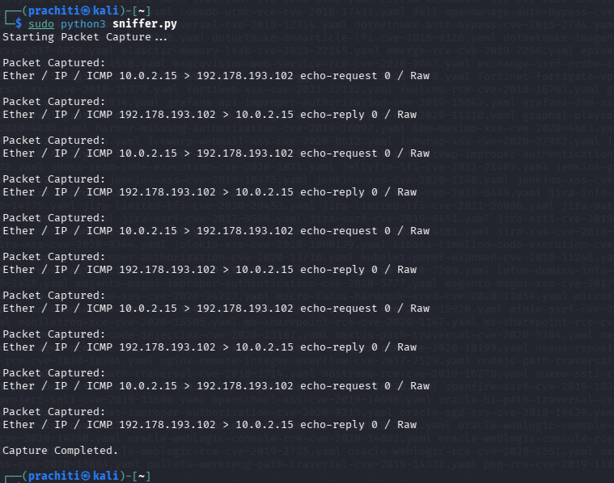
Figure 2: ICMP packets captured successfully using the Python-based Network Sniffer in Kali Linux.

7. Results and Observations
The developed network sniffer successfully captured and displayed live network traffic.
During testing, ICMP Echo Request and Echo Reply packets were observed. These packets indicate successful communication between the local system and a remote host.
The captured packets provided information about:
• Source IP Address
• Destination IP Address
• Protocol Type (ICMP)
• Network Communication Activity
The successful packet capture confirmed that the developed tool was able to monitor network traffic effectively.

8. Learning Outcome
Through this project, I gained practical knowledge of packet sniffing and network traffic analysis.
I learned:
• Basics of network packet communication.
• Working of the ICMP protocol.
• Packet capturing using Scapy.
• Real-time network monitoring techniques.
• Application of Python in cybersecurity.
This project improved my understanding of networking concepts and practical cybersecurity tools.

9. Conclusion
The Basic Network Sniffer project was successfully implemented using Python and Scapy in Kali Linux.
The application captured live network packets and displayed meaningful packet information. The project provided valuable hands-on experience in packet analysis and network monitoring.
This task strengthened my understanding of network communication, packet structures, and cybersecurity monitoring techniques.

References
- Scapy Official Documentation
- Python Official Documentation
- Kali Linux Documentation

